**MANSI UNIYAL**

**19EE10039**

NO LOAD TEST

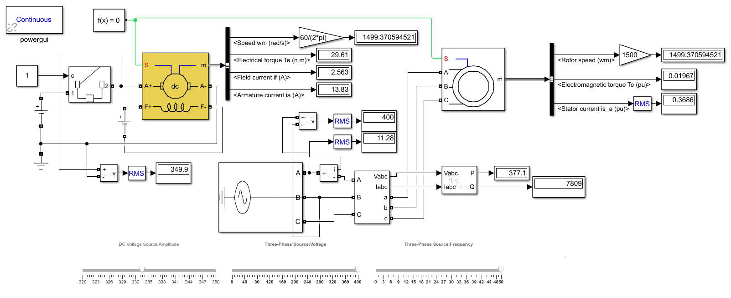

| VS,line | IS,line | Pin(3 − φ) | Qin(3 − φ) | Nr |
| --- | --- | --- | --- | --- |
| 400 | 11.28 | 377.1 | 7809 | 1499.3706 |

BLOCK ROTOR TEST

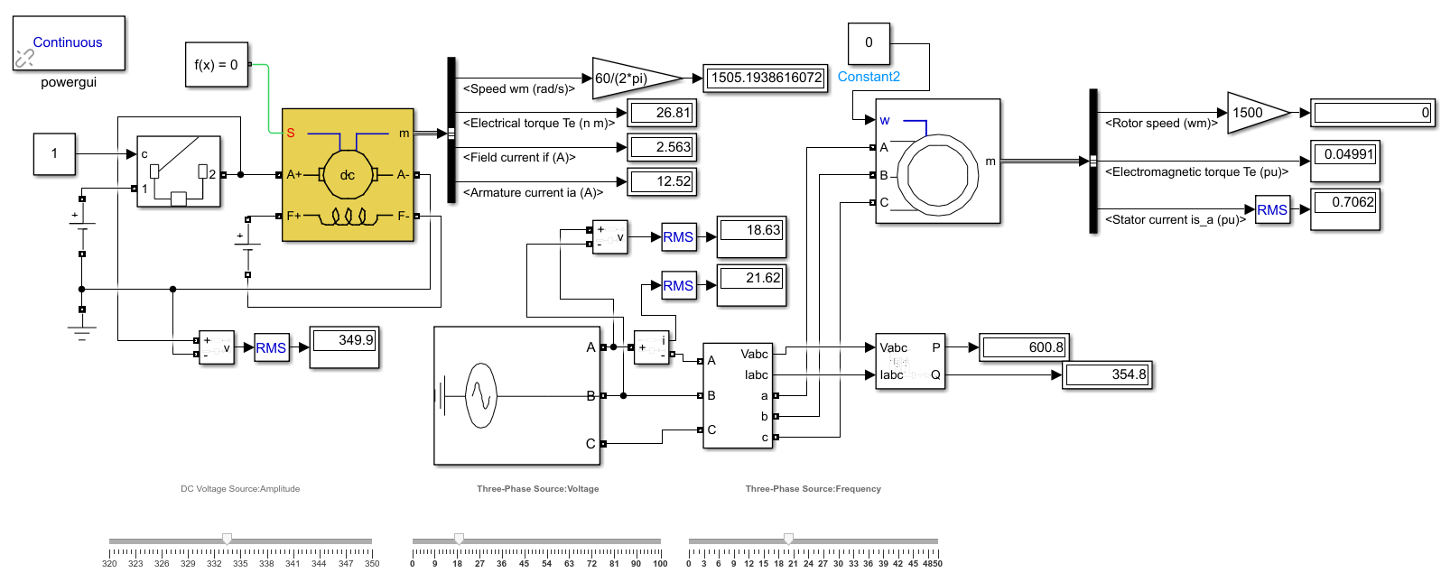

| VS,line | IS,line | Pin(3 − φ) | Qin(3 − φ) |
| --- | --- | --- | --- |
| 18.63 | 21.62 | 600.8 | 354.8 |

LOAD TEST

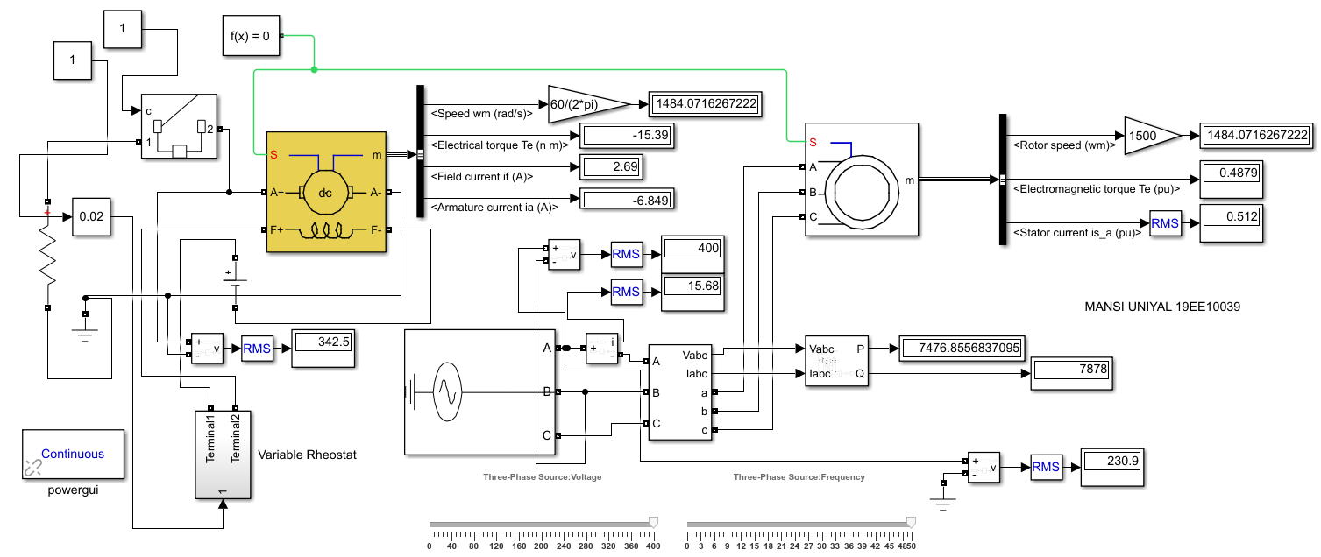

|  | Induction Motor | | | | | DC Motor | |
| --- | --- | --- | --- | --- | --- | --- | --- |
| Rload | Vph | Iph | Nr(rpm) | Pout(watt) | Te(Nm) | Va | Ia |
| 30 | 230.9 | 17.39 | 1480.62 | 9053.78 | 0.5906 | 337.4 | -11.24 |
| 50 | 230.9 | 15.68 | 1484.07 | 7476.86 | 0.4879 | 342.5 | -6.849 |
| 80 | 230.9 | 14.77 | 1486.04 | 6571.5 | 0.4287 | 345.5 | -4.318 |

GRID TEST

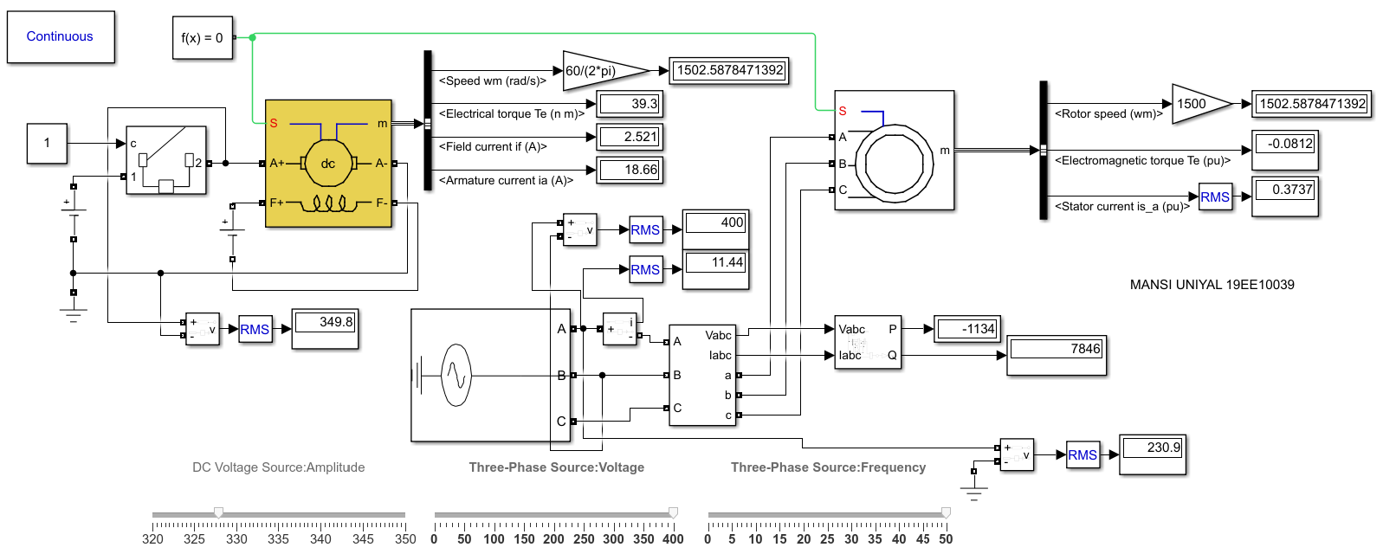

| Induction Motor | | | | | DC Motor | | | |
| --- | --- | --- | --- | --- | --- | --- | --- | --- |
| Vph | Iph | Nr(rpm) | Pout(watt) | Te(Nm) | Va | Ia | Vf | If |
| 230.9 | 11.44 | 1502.58 | -1134 | -8.12 | 349.8 | 18.66 | 327.94 | 2.52 |
| 230.9 | 11.49 | 1503 | -1422 | -9.04 | 349.8 | 19.2 | 327.94 | 2.52 |
| 230.9 | 11.70 | 1504.2 | -2073 | -13.60 | 349.8 | 21.3 | 327.94 | 2.49 |
| 230.9 | 11.97 | 1505.5 | -2708 | -17.18 | 349.8 | 23.3 | 327.94 | 2.48 |
| 230.9 | 12.67 | 1508 | -3935 | -24.92 | 349.8 | 27.4 | 327.94 | 2.46 |

**Calculations:**

**NO LOAD TEST**

Vs, line = 400 V

Is, line = 11.28 A

Pin = 377.1 W

Qin = 7809 VAR

Nr = 1499.3706 rpm

Te = 0.01967 Nm

Xnl = Qin/3*(Is, line^2) = 20.45766 ohm

Xm = Xnl = 20.46 ohm

Lm = Xm/2*pi*50 = 0.06512 H

Pcu,nl = Pin - Prot = Pin - Te*w = 374.61 W

Pcu,nl = 3*Inl^2*Rs

Rs = 0.9813 ohm

**BLOCKED ROTOR TEST**

Vs = 18.63 V

Is = 21.62 A

Pin = 600.8 W

Qin = 354.8 VAR

Xb = Qin/3*(Is^2) = 0.253 ohm

Rb = Pin/3*(Is^2) = 0.42845 ohm

Zb = Rs+jXs+(R’r+jX’r)||jXm = Rb+jXb

Xb = Xs +X’r*(Xm/(X’r+Xm))

R’r = Rb -Rs*((X’r+Xm)/Xm)^2

Xs=X’r=k; k^2+k*40.667-5.176=0

Xs = X’r = k = 0.127 ohm

Ls = L’r = k/(2*pi*20) = 0.00101 H

R’r = 0.961 ohm

**GRAPHS:**

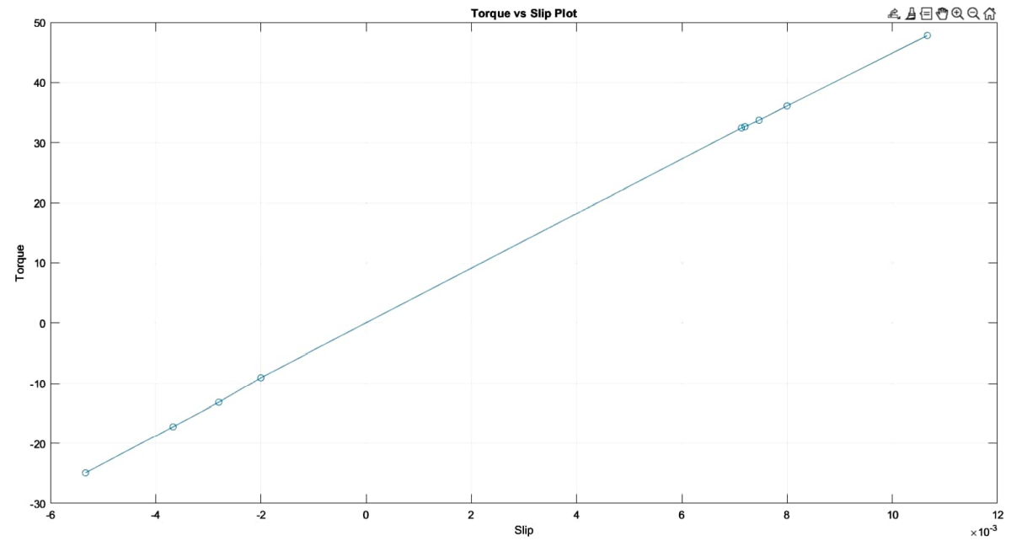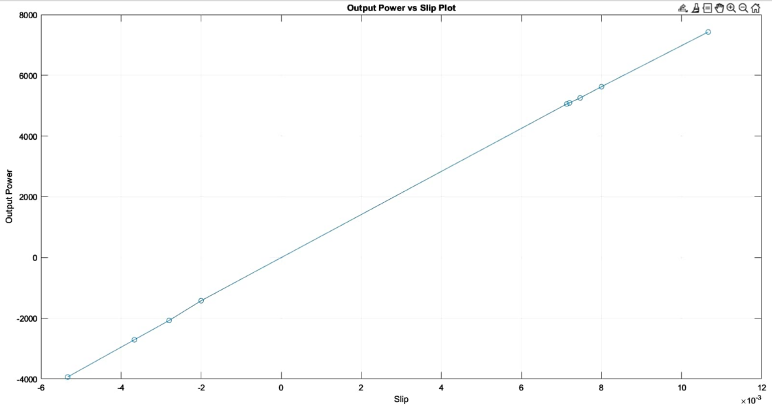

**Discussion Questions:**

1. While conducting the No-Load test, even though there is no-load, why watt-meter reading is not zero?

1. Which loss in the machine is significant in the no-load test and why?
2. Which loss in the machine is significant in the blocked rotor test and why?
3. When r’2/s is split into a series connection of r’2 and r’2{1/s − 1} in the rotor equivalent circuit of an induction machine, what do the power absorbed by the individual resistors physically represent?
4. What are the different losses that are present in an induction machine?
5. Back calculate the power delivered to the rotor at rated slip condition and Comment the calculated power is matching with the nameplate details or not.